PWR stands for Pressurized Water Reactor, which uses ordinary water as both coolant and moderator, keeping it under pressure to prevent boiling and generate steam for electricity. PHWR, or Pressurized Heavy Water Reactor, uses heavy water as coolant and moderator, allowing it to utilize natural uranium as fuel, which can be more economical despite the higher cost of heavy water
BETA , LAMBDA , GEN_TIME – proof given
Cp_F- (specific heat of uranium dioxide )
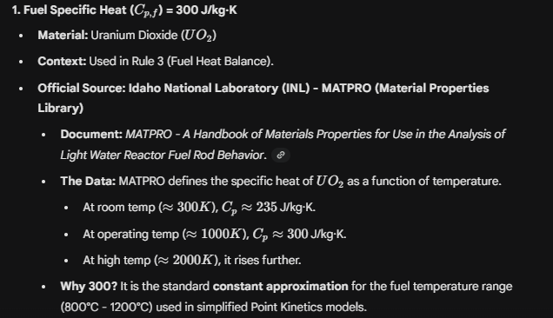
CP_C ( Coolant specific heat of heavy water )
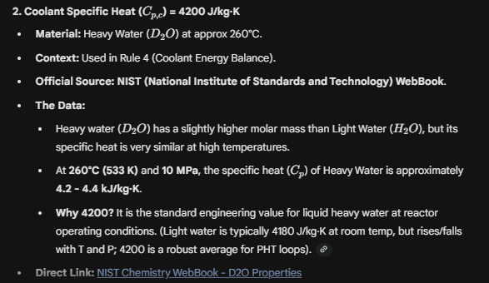
UA – Heat Transfer
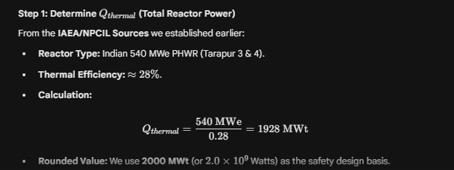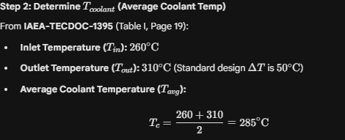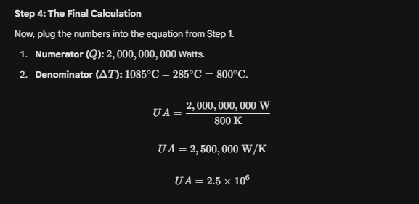
W_nominal ( Nominal Flow)
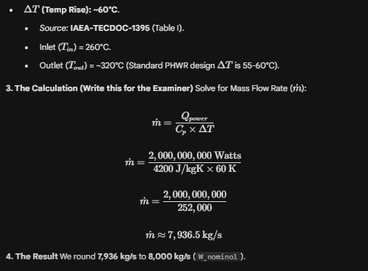
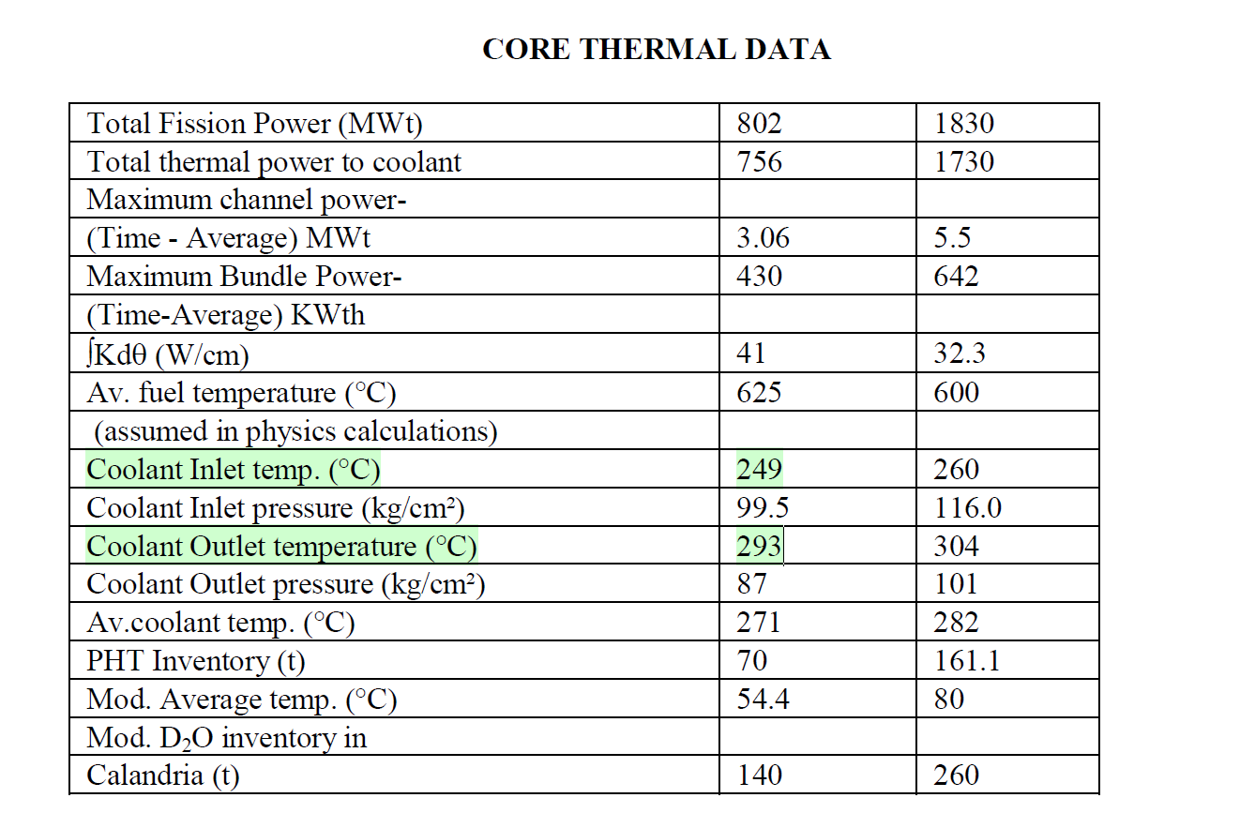 https://www.aerb.gov.in/storage/uploads/documents/regdocFAak2.pdf
Tin & P_nominal (The temperature and Pressure)
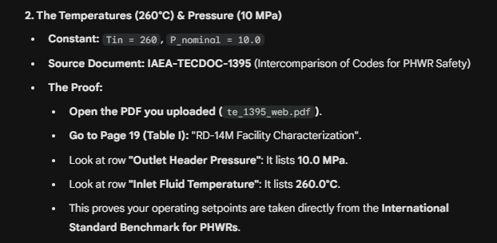
Pg 5 & 89
The Power Rating: 2000 MW (Thermal)
- Constant: 2000e6 (Watts)
- Source Document: IAEA Country Nuclear Power Profile (CNPP) – India
- The Proof:
  - Indian PHWRs come in two standard sizes: 220 MWe and 540 MWe.
  - https://www.npcil.nic.in/content/253_1_OperatingPerformance.aspx

  - The 540 MWe units (at Tarapur) have a thermal efficiency of approx 28%.
  - We round this to 2000 MWt for the "Design Basis Safety Analysis" limit.
- Link: IAEA CNPP India Profile (Look for Table 1: Power Plants).
https://pris.iaea.org/PRIS/CountryStatistics/ReactorDetails.aspx?current=301

